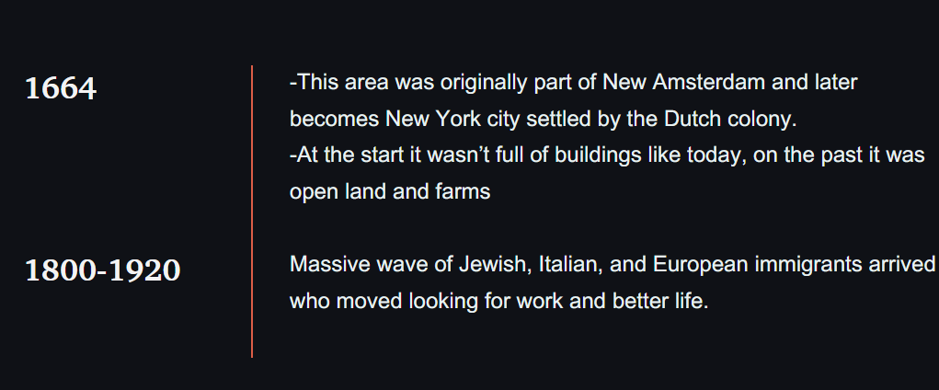

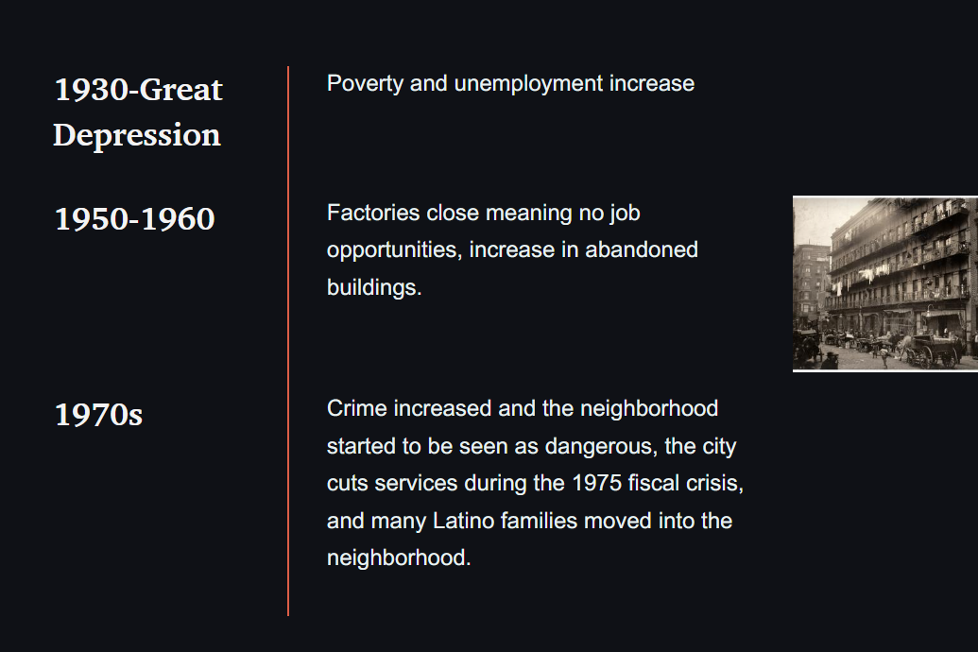

- To create the timeline, we selected the time and added the years on the left, and added the description on the right.
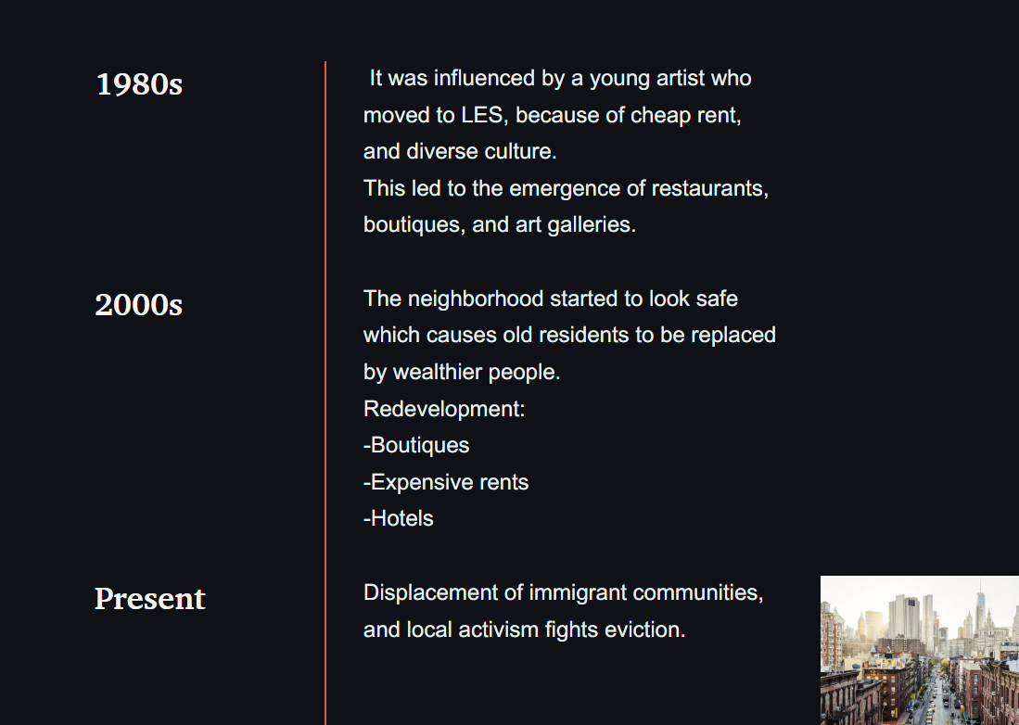
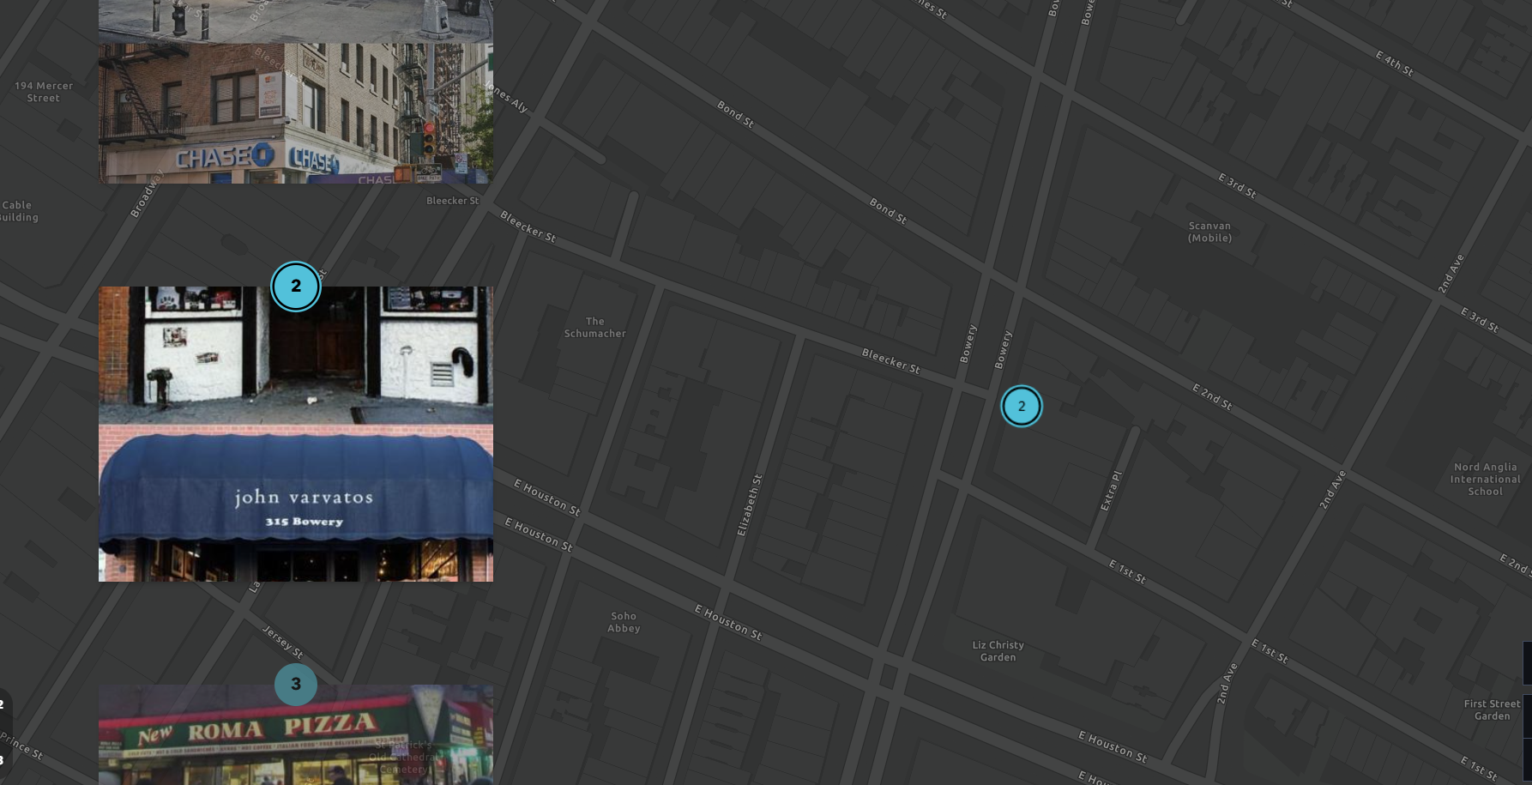
- This is a sidecar slideshow. Depicting images and a map that shows where these locations are.
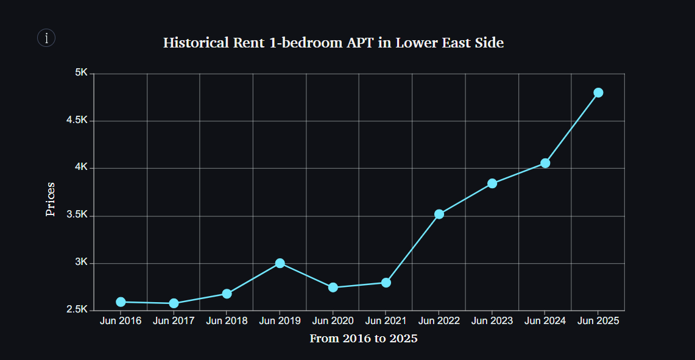

- In the story map, after clicking the chart, we inserted a line graph to depict the rising cost of rent for a 1-bedroom apartment in the Lower East Side
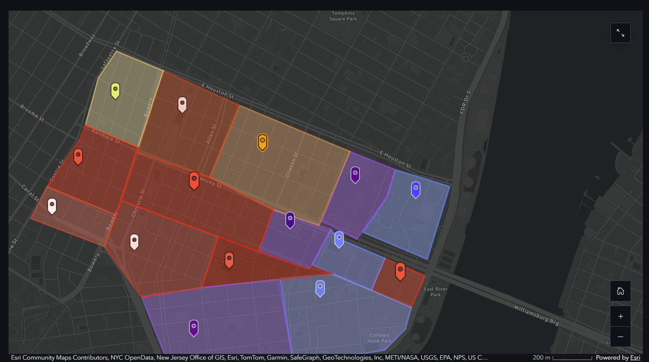

- We added a map. Sectioned off the Lower East Side into different areas, giving a brief description of gentrification risk, and whether there is any displacement of people

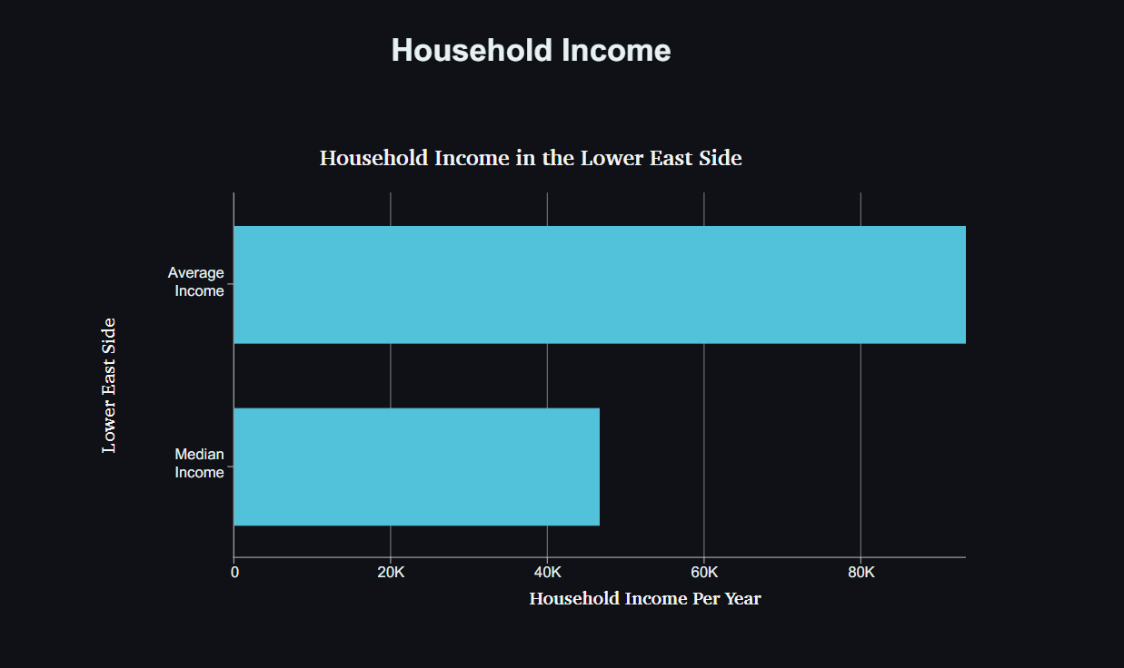


- For this bar graph, we added a chart displaying the median and average income per year.

- For the video, we selected a video and inserted a file

